**Ideation Phase**

**Brainstorm & Idea Prioritization Template**

|  |  |
| --- | --- |
| Date | 15 February 2026 |
| Team ID | LTVIP2026TMIDS87366 |
| Project Name | Prosperity Prognosticator: Machine Learning for Startup Success Prediction |
| Maximum Marks |  |

Reference: <https://www.mural.co/templates/brainstorm-and-idea-prioritization>

**Step-1: Team Gathering, Collaboration and Select the Problem Statement**

During the ideation phase, the team discussed various real-world problems where machine learning could be applied. Different domains such as healthcare prediction, student performance analysis, and financial decision support were considered.

After discussion, the team selected the problem of startup success prediction. Many startups fail due to lack of funding, weak planning, or insufficient market support. Investors and entrepreneurs need a system that can help estimate the chances of startup success.

Hence, the project titled “Prosperity Prognosticator – Startup Success Prediction using Machine Learning” was finalized.

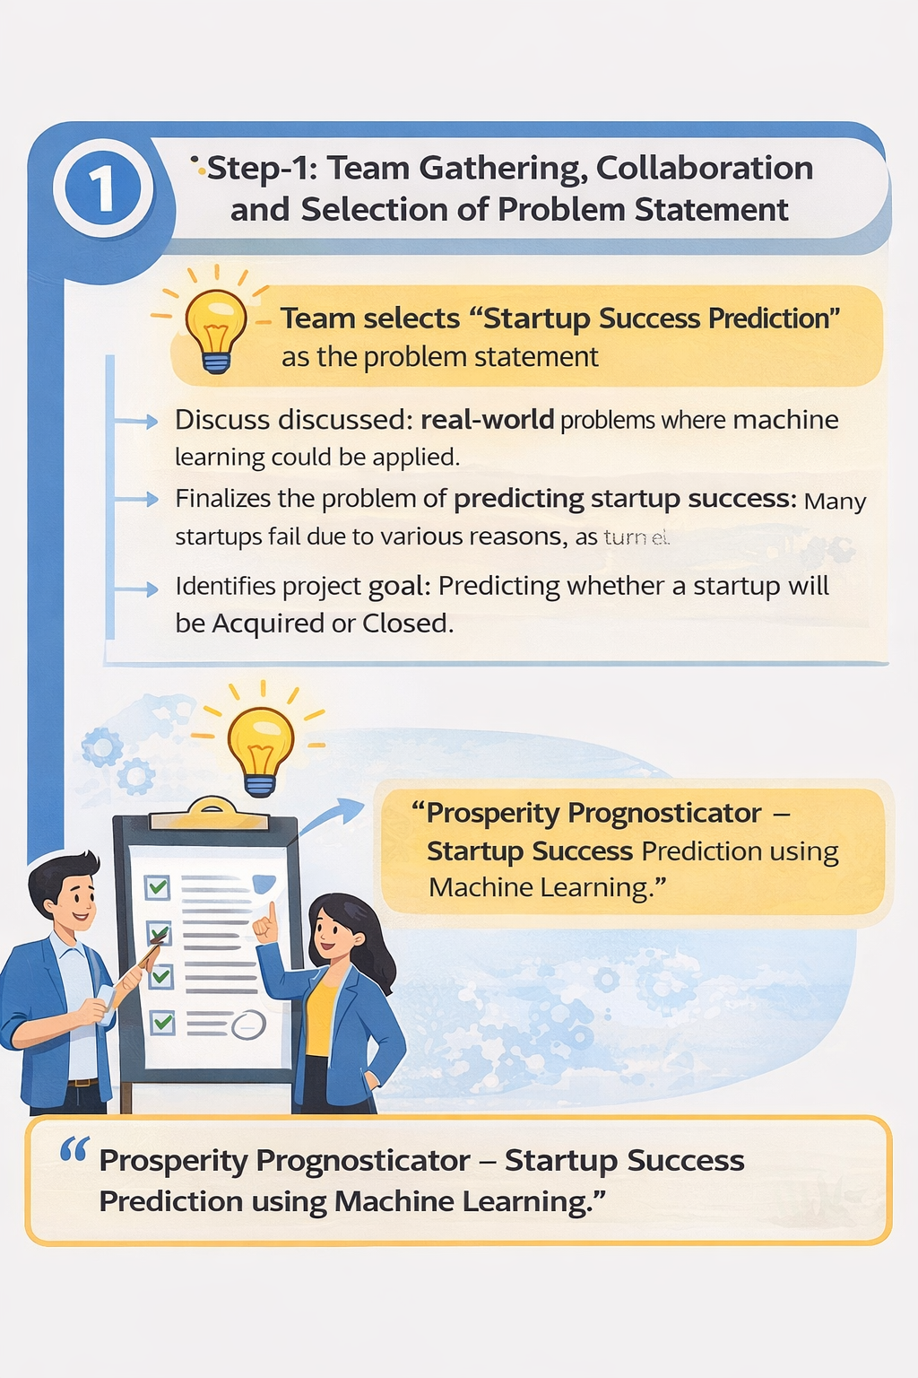

**Step-2: Brainstorm, Idea Listing and Grouping**

In this stage, the team brainstormed multiple ideas on how to solve the selected problem using machine learning techniques.

The following ideas were proposed:

* Analyze startup funding and milestone data
* Identify important features affecting startup success
* Train a classification model for prediction
* Compare algorithms and choose the best one
* Build a web application to allow users to test predictions

After discussion, these ideas were grouped into three main components:

1. **Data Analysis** – Understanding startup data and selecting important features
2. **Model Building** – Training and evaluating a machine learning model
3. **Deployment** – Creating a web application for real-time prediction

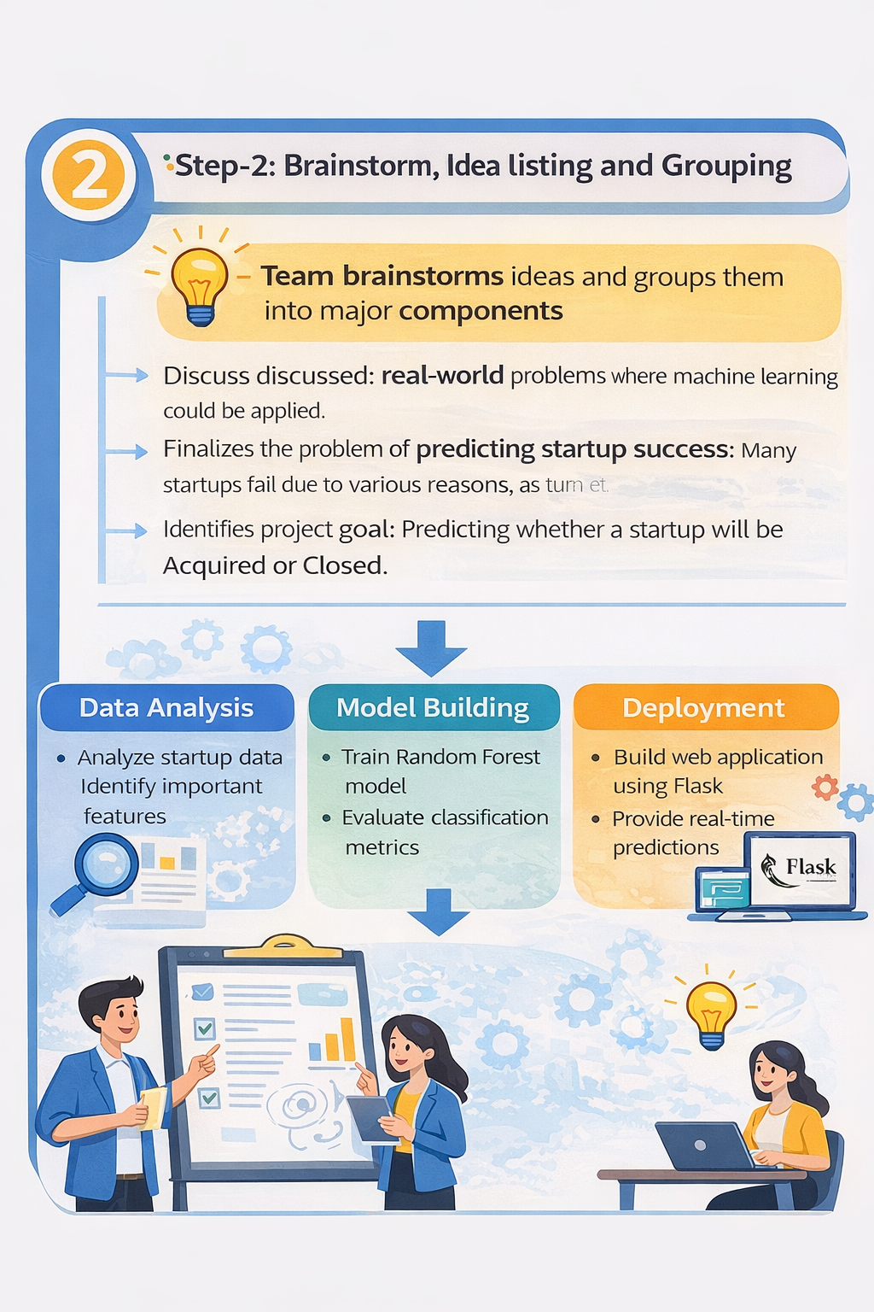

**Step-3: Idea Prioritization**

After brainstorming, the ideas were evaluated based on feasibility, learning value, and practical implementation.

The team finalized the following approach:

* Use historical startup dataset for analysis
* Apply **Random Forest Classifier** for prediction
* Evaluate model using accuracy, classification report, and confusion matrix
* Develop a Flask web application for deployment
* Provide prediction results with confidence score

This approach was prioritized because it demonstrates the complete machine learning pipeline and solves a real-world business problem.

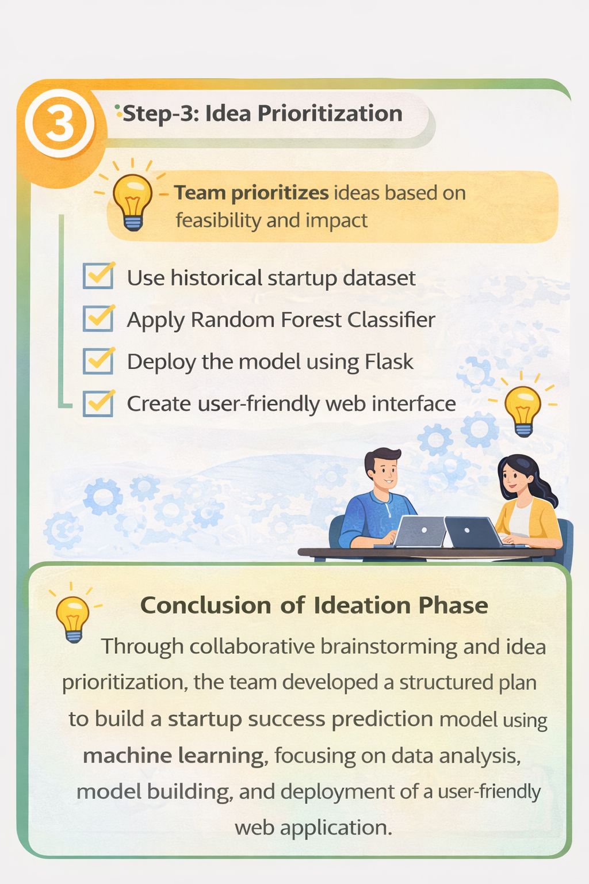

**Step-4: Finalization of Solution Approach**

After prioritizing ideas, the team finalized the complete solution workflow for the project.

The final approach includes:

* Data collection and preprocessing
* Feature selection and model training
* Prediction using Random Forest classifier
* Model evaluation using performance metrics
* Deployment using Flask web framework
* Providing a user-friendly interface for prediction

**Conclusion of Ideation Phase**

Through brainstorming and idea prioritization, the team developed a structured plan to build a startup success prediction system using machine learning. The finalized approach integrates data analysis, model development, and deployment, making the project practical and suitable for real-world use.